**VPC Peering:**

* Create a VPC
* Create a Private Subnet and public subnet
* Create a internet gateway on the VPC
* Create the RT for both public and private subnet
* For public RT, map the subnet and route the IGW
* Create the NAT Gateway
* For private RT, map the subnet and route the NAT
* Create EC2 instances(Public and Private) and allow the SSH port and all traffic
* In this assignment, we are going to peer VPCs between 2 accounts.
* We need to make sure CIDR doesn’t overlap between the VPCs

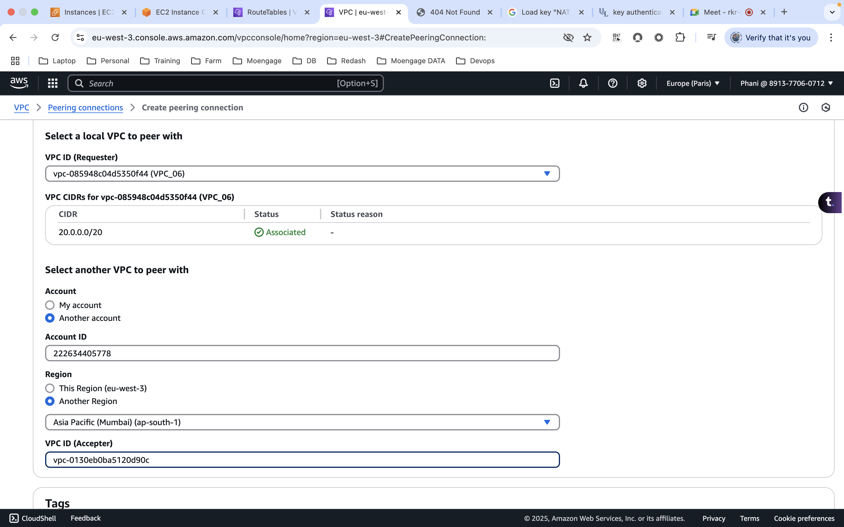

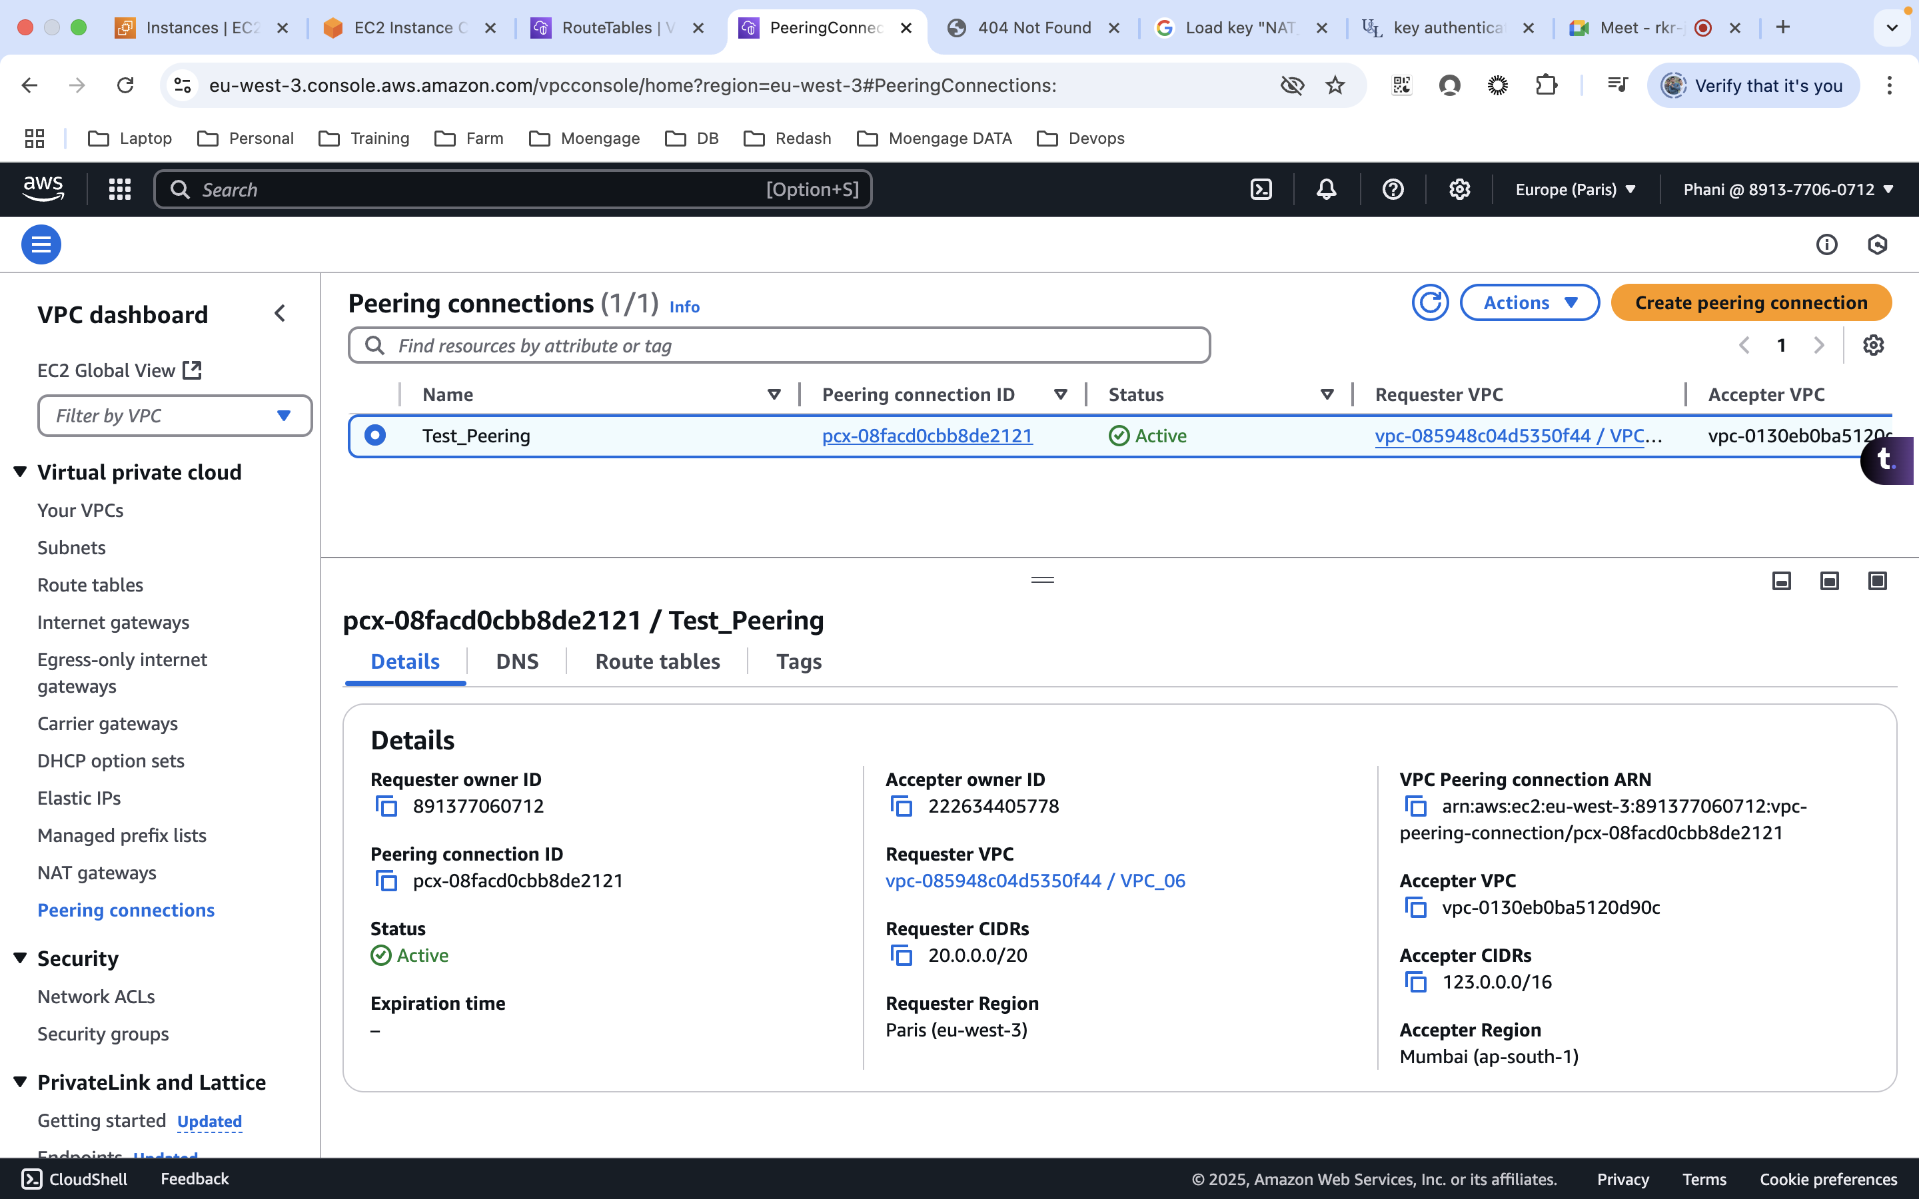

* Once the connection is done, please update the route table accordingly.
* If we want to connect to the Public EC2 on the other account, we need to add the route (Subnet CIDR) to the public RT on both the accounts.
* Ping to the Public instance on the other account(Public IP)  
  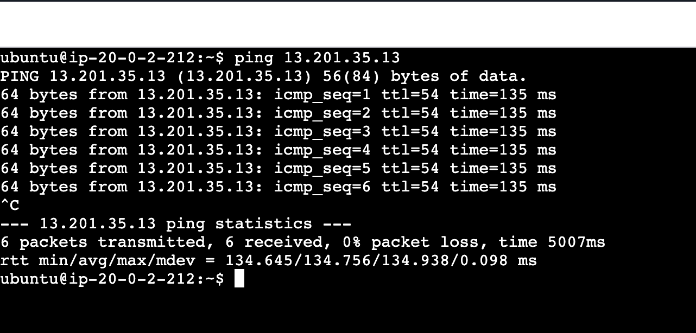
* Add the CIDR values under the route tables for the both the accounts  
  A screenshot of a computer

  AI-generated content may be incorrect.  
  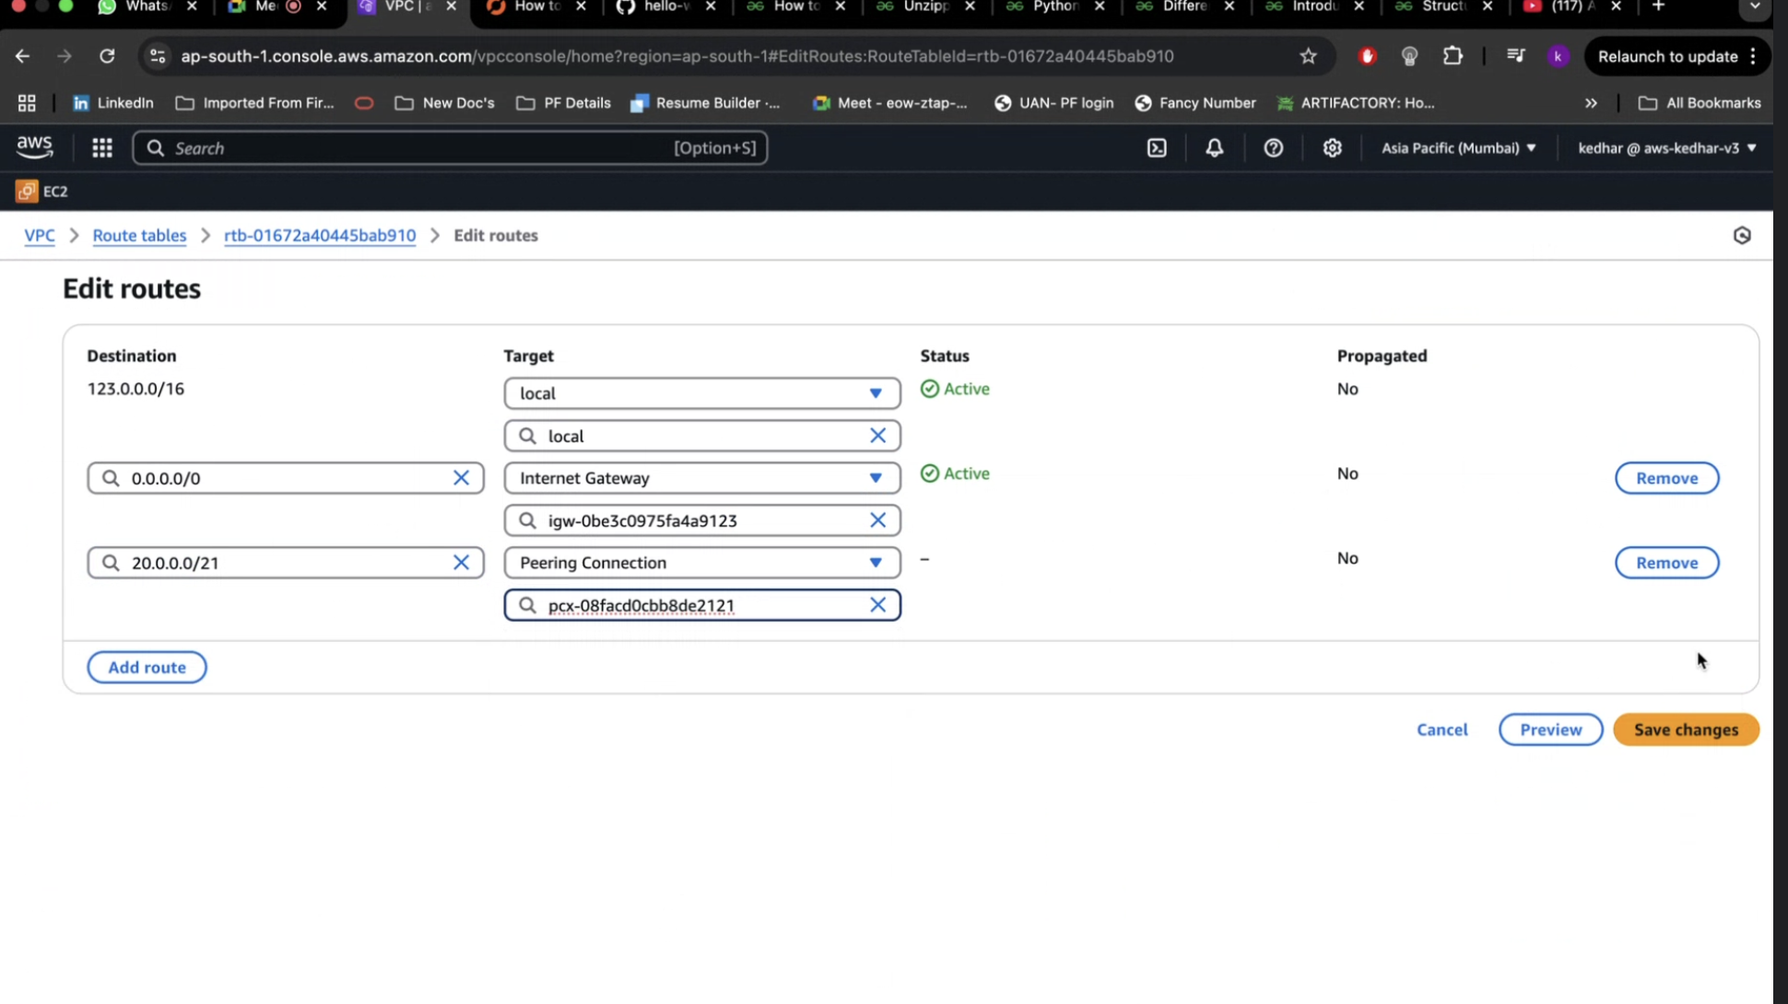
* Ping to the Private IP after adding the RT  
  A computer screen with white text

  AI-generated content may be incorrect.
* SSH into the public machine using pem file  
  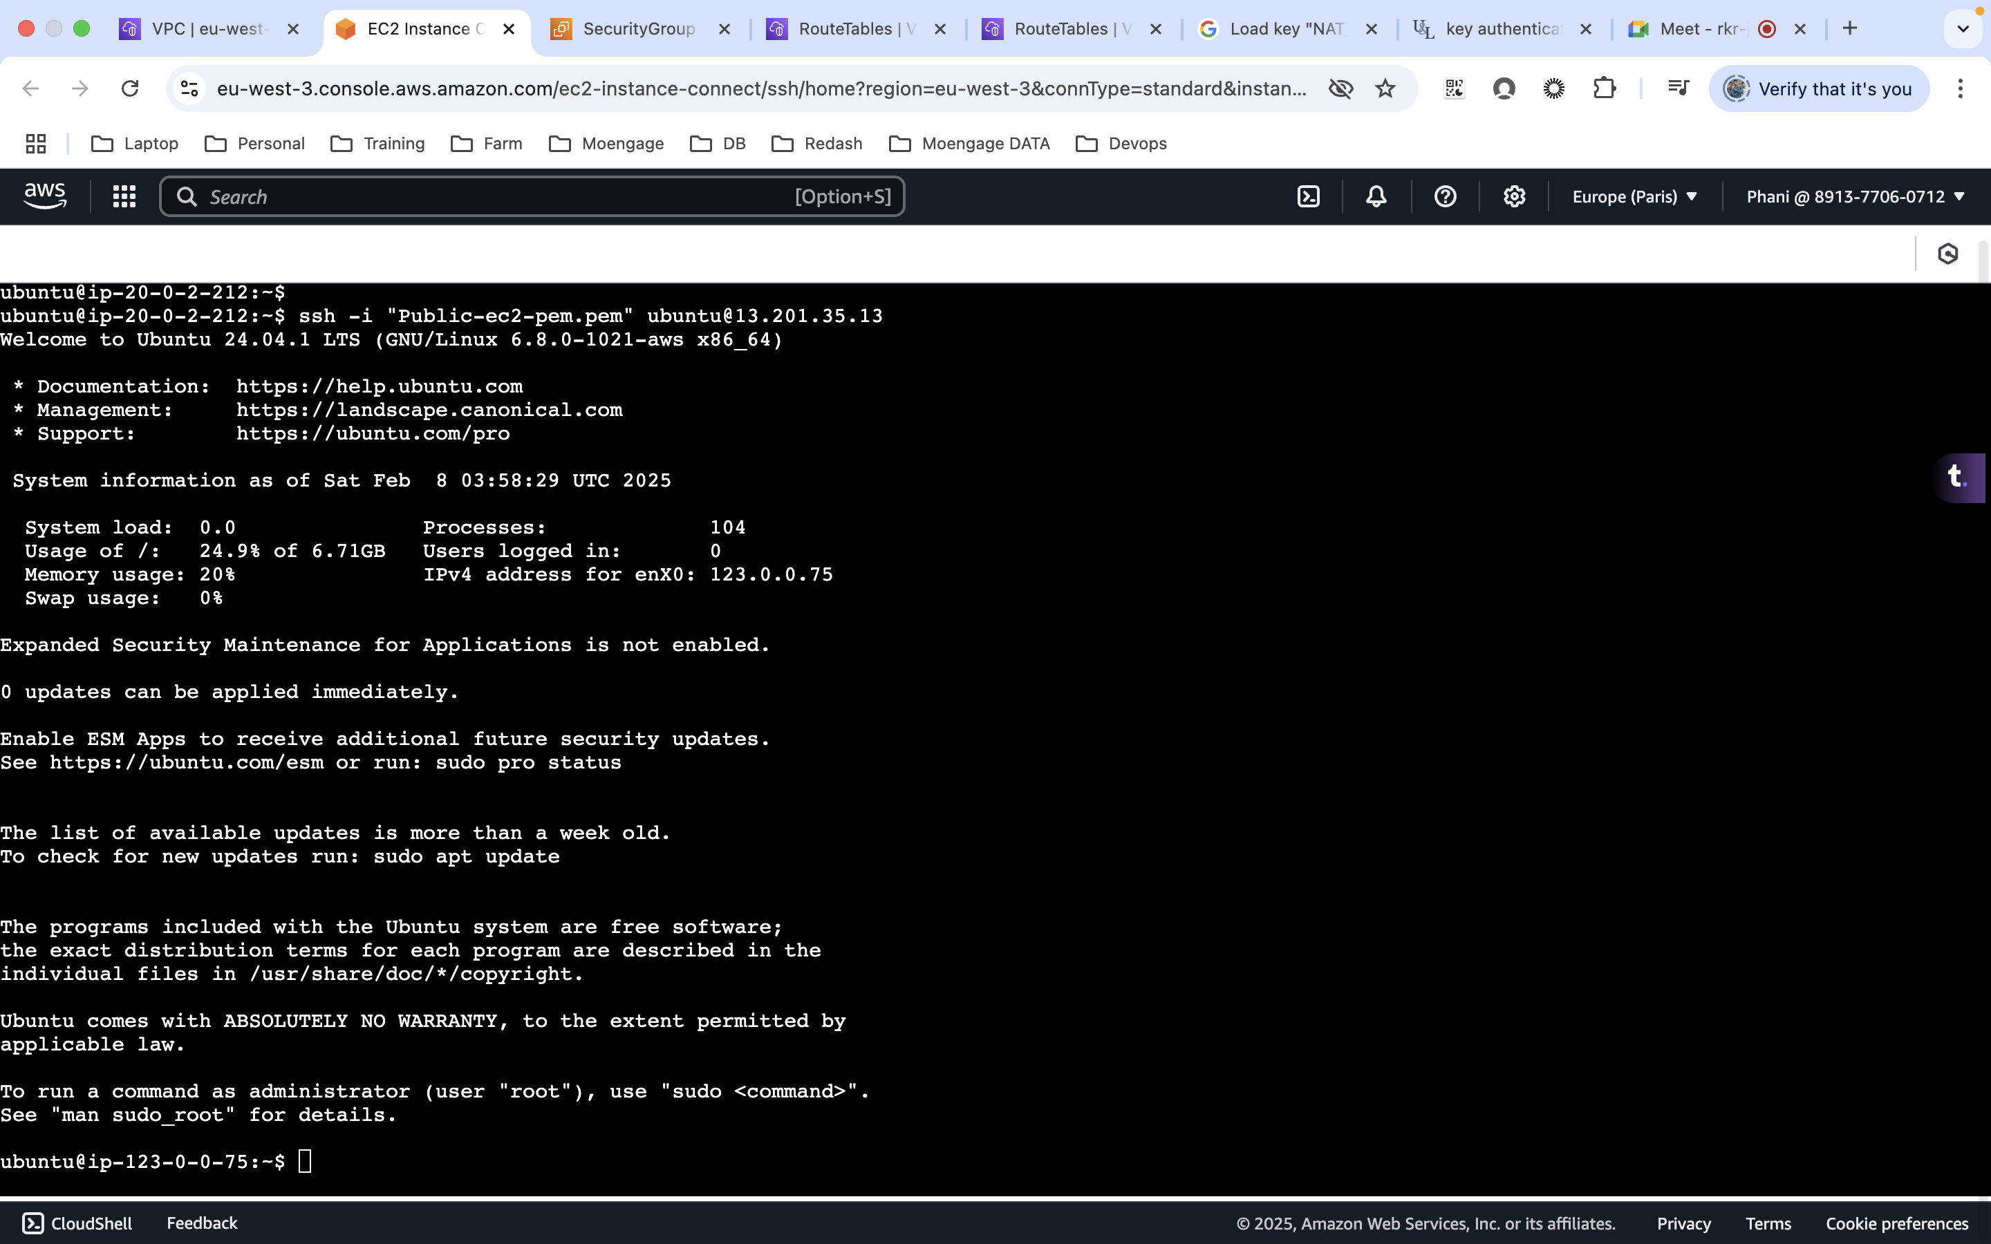
* update the RT on the other account private RT, so that I can access the private EC2 from my public EC2  
  
 